Name: Lastname, Firstname
Project: Project Name
Change Number:
Date: mm/dd/yyyy
Group Number:

Everything in italics should be replaced as appropriate by you and should not be italic when submitted. Also remember code is not changed until the Actualization stage, so don’t put words like “I changed” or similar until section 5 of the report.

(Title of the change request)

- Change Request:
In this section, describe the change that you were requested to do. Give any relevant background information or any essential details.

- Concept Location:
Explain the methodology that you have used to locate each concept that was part of your change request. Using Table 1 (expand if necessary), list all the files in the order that you have visited them (2nd column). Explain how you have found each file (3rd column). You can simply read the source code, but we encourage you to use the features provided by Eclipse shown in the class (right-click class and method names to find these exploration tools). You are also encouraged to use other tools if you wish, such as JRipples. In the fourth column, mention whether the class is related to the concept or not. Use one of the following terms (from the textbook):
- Use “Unchanged” if the class has no relation to the concept but you have visited it.
- Use “Propagating” if you read the source code of the class and it guided you to the location of the concept, but you will not change it.
- Use “Changed” if the class will be changed.
In the fifth column, write what you have learned about the class.

Table 1: The list of all the classes visited during concept location
# | File name | Tool used | Located? | Comments

- Impact Analysis:
Using Table 2, list the classes that you visited after you located the concept. On the first row, include the class where you have located the concept, i.e. the class that will be changed (2nd column). Explain how you have found each of the classes, i.e. which tools have you used (3rd column). Do you think that the class will be impacted by the change? (4th column) Write short comments explaining what have you learned about each class. What other tools you would like to have in Eclipse so that impact analysis would be faster?

Table 2: The list of all the classes visited during impact analysis
# | Class name | Tool used | Impacted? | Comments

- Learning process: Include a partial UML class diagram (replace the example below). The class diagram must contain all the classes that you visited and all the relations (dependencies) between the classes that you understood. (see Figure 1). Mark the classes that were changed with red text as in the example (or some other way). Feel free to use a tool to draw these for you (see ObjectAid.com or Violet UML Editor before you make this by hand).

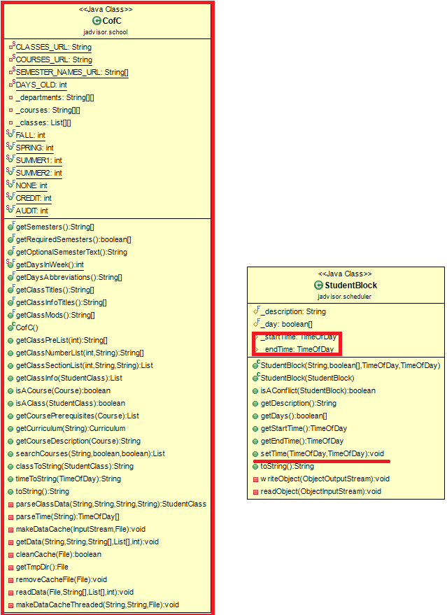
Figure 1. Class Diagram After Chris Cargile Edits

- Description of the implementation:
Explain where and why you made changes in the source code. Which classes or methods you created, or changed.

- Sources: Include any sources that you cited or used information from (if applicable).

- Highlighted Source Code:
Attach or cut and paste the code of the classes that you changed. Highlight the code that was changed or added. Use YELLOW for modified code, RED for deleted code, and GREEN for added code. If you only changed one method in a large file, only include that method and the file name it’s from. Likewise, if you only changed a line or two in an event map or resource file, only include a few of the surrounding lines and the file name. Do not include thousands of lines of code that you did not change!

